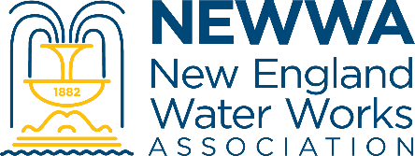
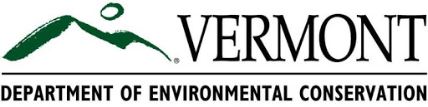

Vermont Legacy Distribution Operator Certiﬁcation
Upcoming Training Schedule

Are you a Vermont Drinking Water Treatment Operator working at a system that will require a certiﬁed Distribution operator by July 1, 2029? The State of Vermont is oﬀering a limited time opportunity for qualiﬁed treatment operators to obtain their Legacy Distribution Certiﬁcation without taking the distribution class exam.

Through a state-provided, no-cost, one day training course, eligible participants may earn a “Legacy Distribution” certiﬁcation based on their prior experience and successful completion of the course. Sessions will be held at locations across the state throughout the coming year to ensure accessibility for operators in all regions
Who Should Attend?

This training is available to operators who have passed a Vermont treatment exam (Class 2, 3, or 4) AND can document 1.5 years of experience working at an eligible water system (by 7/1/2029) that meets the *“Distribution” deﬁnition. PLEASE NOTE: Legacy Distribution Certiﬁcations are non-transferable. If you begin working at a diﬀerent water system after receiving this legacy certiﬁcation, you will need to take and pass the distribution class exam to be licensed at the new system.

*"Distribution" is defined by the following:

Community water systems that serve 500 or more people and have either fire hydrants connected to the distribution system or distribution booster pump stations (NOTE: this does not include a central pump station that serves all users, it is a booster pump station within the distribution that is owned/operated by the water system or otherwise identified in the system’s Permit to Operate). It also applies to consecutive community water systems who purchase their water and serve more than 500 people.

Non-Transient Non-Community water systems that serve 500 or more people and have fire hydrants connected to the distribution system.

For details on eligibility and licensing requirements, visit the VT DEC website.

What You'll Learn

This training session goes far beyond the basics. It is designed to equip operators with the practical knowledge and technical skills necessary to maintain and manage water distribution systems. Topics include:

Pressure zones, hydraulic grade lines, and system growth

Uni-directional ﬂushing and scouring velocities

Fire ﬂow testing and emergency response

Backﬂow prevention and legal requirements

Valve and pump station maintenance

Water quality monitoring and leak detection

Regulatory procedures, including boil notices and public reporting

Upcoming Training Dates
Please note that the classes currently scheduled are just the beginning! We’re actively planning more sessions in additional locations, so if you are unable to attend these sessions, don’t panic — there will be plenty of other opportunities coming soon.

Brattleboro Session
Date: Monday, October 6, 2025
Time: 8:30 AM – 3:45 PM
Location: Brattleboro Fire Department – Central Station, 103 Elliot St., Brattleboro, VT
Credits: 6 TCHs
Register Here: https://communityhub.newwa.org/event-information?id=a0lUa000003VvhpIAC

Springfield Session
Date: Monday, October 20, 2025
Time: 8:30 AM – 3:45 PM
Location: Springfield VT DEC Regional Office, 100 Mineral Street, Suite 303, Springfield, VT
Credits: 6 TCHs
Register Here: https://communityhub.newwa.org/event-information?id=a0lUa000003WTUzIAO

Rutland Session
Date: Monday, November 3, 2025
Time: 8:30 AM – 3:45 PM
Location: Rutland Regional Planning Commission, 16 Evelyn St., Rutland, VT
Credits: 6 TCHs
Register Here: https://communityhub.newwa.org/event-information?id=a0lUa000003VwSbIAK

