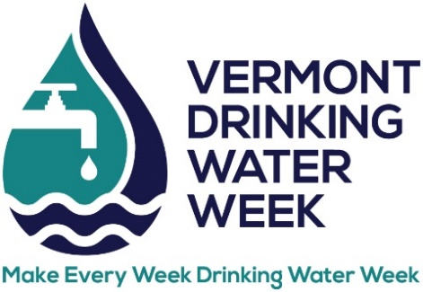
DRINKING WATER TASTE TEST
ENTRY FORM

Think you have the best tasting water in Vermont? Enter the 2025 Drinking Water Taste Test which will be held during Vermont Rural Water’s Annual Conference at Lake Morey Resort.

Date: Thursday, May 15, 2025
Time: Deliver samples by 9 am. Judging starts at 9:30 am.
Location: Lake Morey Resort, 82 Clubhouse Rd, Fairlee, VT

Water system: _____________________________________________________

WSID: ____________________________________________________________

Contact name: ______________________________________________________

Phone number: _____________________________________________________

Email: _____________________________________________________________

Category (circle one):

CWS – Surface Water CWS – Groundwater NTNC TNC

Please send form to info@vtruralwater.org by Friday, May 2, 2025.

Remember:
- Provide one (1) gallon of water in a container that is clearly marked with water system name, WSID, and category (CWS groundwater, CWS surface water, NTNC, or TNC). Glass containers are strongly recommended.
- Water must be at room temperature. Water that is delivered in coolers or that is not at room temperature will be disqualified.
- Drop off your sample at the taste test table in the lobby by 9 am on May 15.
- Samples should be drawn no earlier than the day before the event.

