**Water Meter Test Bench  
for two-water meters with two calibrated test tanks**

* Manufactured by Ford Meter Box Company, Part Number: FK2STB-LR, Ford Standard 2 Station Test Bench, Left to Right flow path.
* For company specifications see pages K-1, K-2 and K-3 of <https://assets.fordmeterbox.com/pricebook/k/Water-Meter-Test-Bench-Price-Book.pdf>
* All items in **“near new”** condition. Bench and tanks were used by students only 8 hours per year (1968-2009) in a university hydraulics laboratory.
* This water meter test bench package includes the following items:

1. FK2STB-LR Test bench with the following:
   1. **Known defects – Both pressure gages need to be replaced.**
   2. Adapters and gaskets for 5/8”, 5/8” x ¾”, ¾” and 1” meters.
   3. Ball valves at inlet and outlet.
   4. Testerate Indicator (rotometer, see page K-3) to indicate test flow rate.
   5. Pressure gages at inlet and outlet.
   6. Bleeder valve at outlet of each station.
   7. A drain valve at bench outlet.
   8. 18” copper swinging discharge pipe at outlet.
   9. Idler pipe for one meter test station.
   10. Shipping weight legs and shelf box = 85 pounds.
   11. Shipping dimensions legs and shelf box = 32” x 20” x 14”
   12. Shipping weight adapters and gages = 15 pounds.
   13. Shipping dimensions adapters and gages carton = 16” x 12” x 5”
   14. Shipping weight pan and parts = 133 pounds.
   15. Shipping dimensions pan and parts carton = 45” x 18” x 18”
2. FK10-GF, Ford 10 Gallon Calibrated Test Tank with the following:
   1. **Known defects – tank label partially removed.**
   2. Ford calibration label.
   3. Calibrated sight glass.
   4. Ball valve on tank drain.
   5. Shipping weight small tank = 62 pounds.
   6. Shipping dimensions small tank = 10” Dia x 61” H
3. FK100-GF, Ford 100 Gallon Calibrated Test Tank, includes the following:
   1. **Known defects – none.**
   2. Ford calibration label.
   3. Calibrated sight glass.
   4. Swing gate valve on tank drain.
   5. Shipping weight large tank = 210 pounds.
   6. Shipping dimensions large tank = 28” Dia x 61” H.

* Additional parts include the following:
  1. 1” x 12” steel pipe to raise Testerator to eye level.
  2. 38” W x 28” L x 10 ½” H wooden platform to raise tanks.
  3. Shipping weight of platform = 60 pounds.

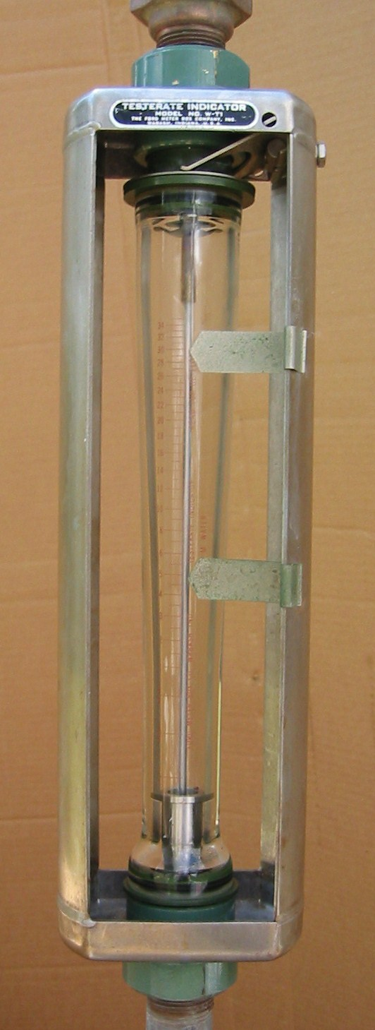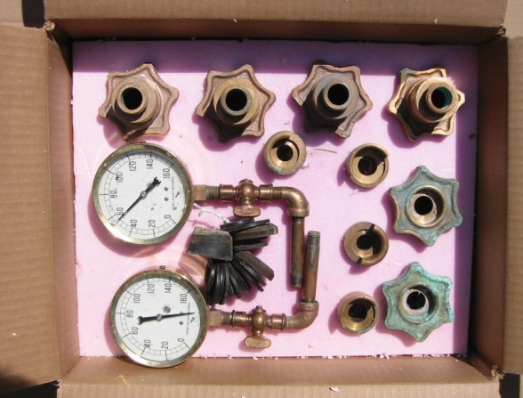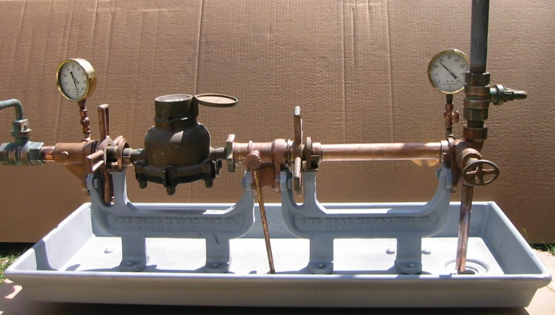

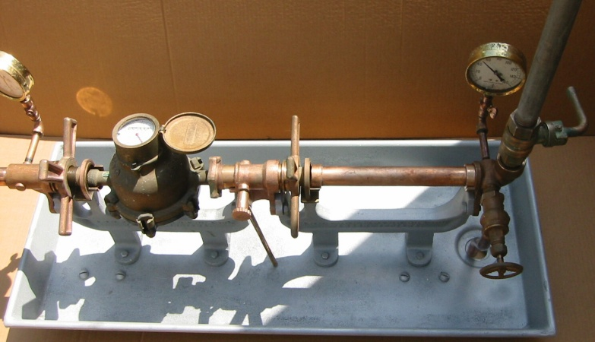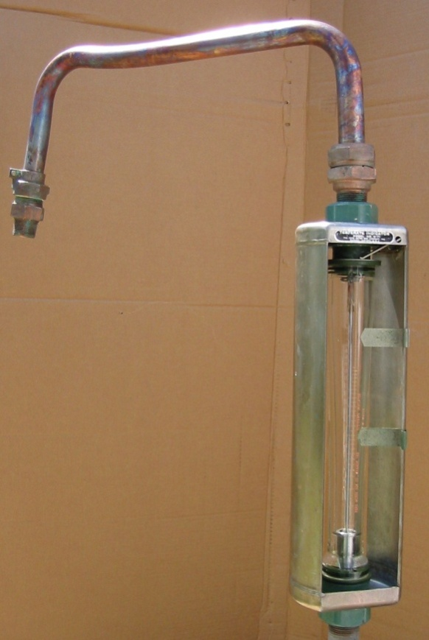

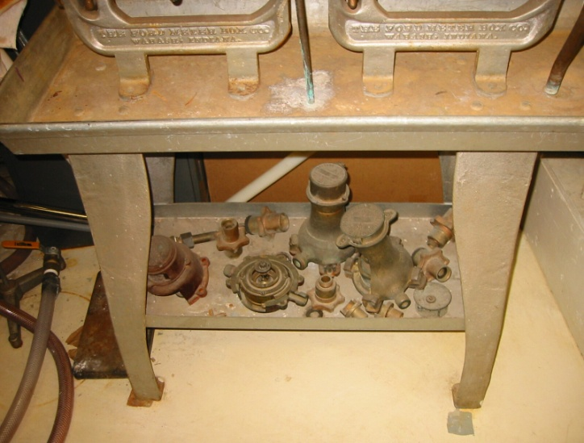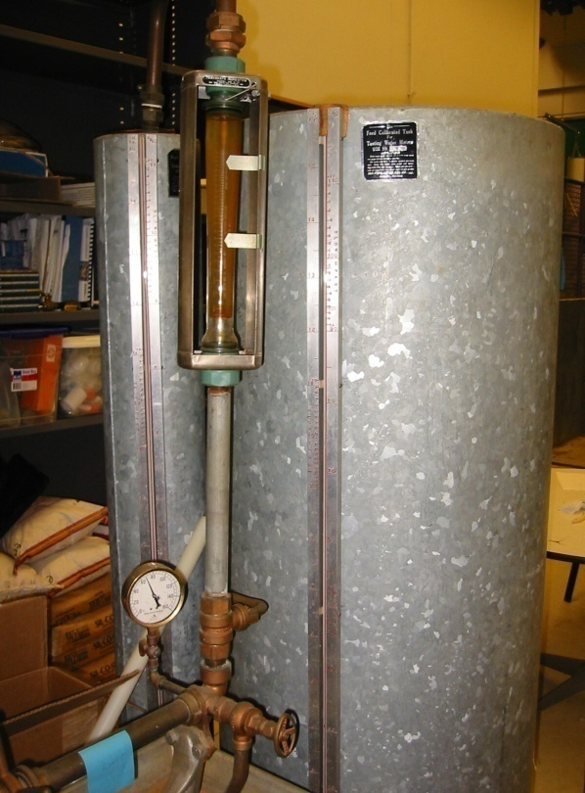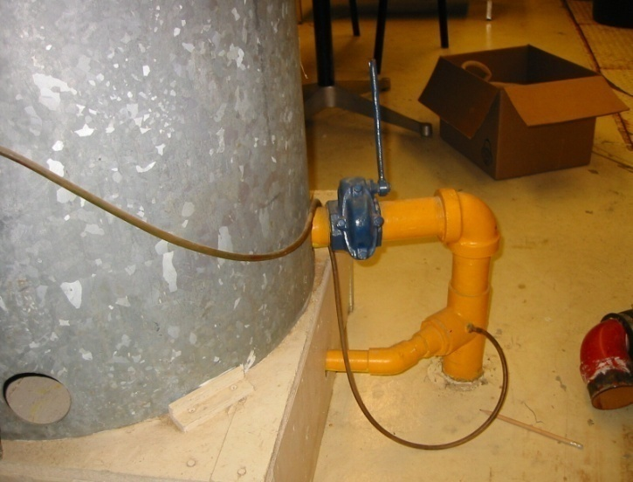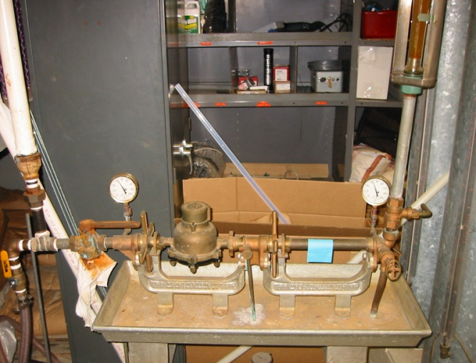Photos before cleanup.