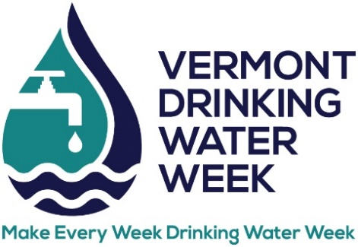
DRINKING WATER TASTE TEST
ENTRY FORM

Think you have the best tasting water in Vermont? Enter the 2024 Drinking Water Taste Test which will be held during Vermont Rural Water’s Annual Conference at Lake Morey Resort.

Date: Thursday, May 9, 2024
Time: Deliver samples by 9 am. Judging starts at 9:30 am.
Location: Lake Morey Resort, 82 Clubhouse Rd, Fairlee, VT

Water system: ________ _________________________________

WSID: _________________ _________________________________________

Contact name: ______________________________________________________

Phone number: ________________________________ ____________________

Email: _________________ ___________________________________

Category (circle one):

CWS – Surface Water CWS – Groundwater NTNC TNC

Please send form to info@vtruralwater.org by April 27

Remember:
- Provide one (1) gallon of water in a container that is clearly marked with water system name, WSID, and category (CWS groundwater, CWS surface water, NTNC, or TNC). Glass containers are strongly recommended.
- Drop off your sample at the taste test table in the lobby by 9 am on May 9.
- Samples should be drawn no earlier than the day before the contest.

