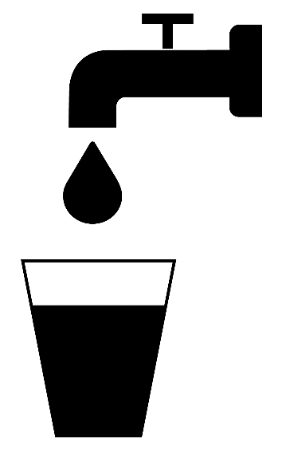
Do you need help paying your water or sewer bill?
The Low Income Household Water Assistance Program (LIHWAP) may be able to help!
This is a federally funded program administered by the Vermont Department for Children and Families (DCF) to help eligible households pay their water and wastewater bills. Applications are due by March 15!
You may be eligible if:
- Income below 60% of the state median based on household size
- Your household includes someone in a vulnerable population (elderly, disabled, child under age 6)
- Unpaid water/sewer bills
- Water/sewer has been disconnected or is at risk of being disconnected
- Your household is eligible for LIHEAP (Seasonal Fuel Assistance), SNAP (3SQVT), and TANF (Reach-UP)
- Renters are eligible. If water/sewer is included in your rent, have your landlord provide a letter explaining how the water/sewer bill(s) are allocated to the rental unit and provide a copy of their bill.
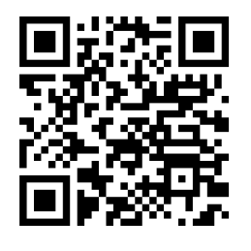
How to Apply
Download the application at dcf.vermont.gov/benefits/hwa
or call 1-800-339-6433 to receive the application by mail.
Send the application and a copy of your water/sewer bill to:
ADPC - Economic Services Division
280 State Drive
Scan for more information and the application
Waterbury, VT 05671-1500

Apply by March 15, 2024!

