This is a federally funded program administered by the Vermont Department for Children and Families (DCF) to help eligible households pay their water and wastewater bills. You may be eligible if you have unpaid water/sewer bills and your income is below 60% of the state median based on household size.

Find more information and apply at dcf.vermont.gov/benefits/hwa  
or call 1-800-339-6433

**Apply by March 15, 2024!**

**Do you need help paying your water or sewer bill?**

The Low Income Household Water Assistance Program (LIHWAP) may be able to help!

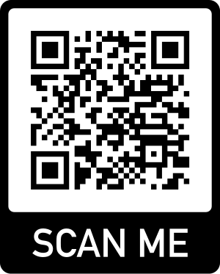

This is a federally funded program administered by the Vermont Department for Children and Families (DCF) to help eligible households pay their water and wastewater bills. You may be eligible if you have unpaid water/sewer bills and your income is below 60% of the state median based on household size.

Find more information and apply at dcf.vermont.gov/benefits/hwa  
or call 1-800-339-6433

**Apply by March 15, 2024!**

**Do you need help paying your water or sewer bill?**

The Low Income Household Water Assistance Program (LIHWAP) may be able to help!

This is a federally funded program administered by the Vermont Department for Children and Families (DCF) to help eligible households pay their water and wastewater bills. You may be eligible if you have unpaid water/sewer bills and your income is below 60% of the state median based on household size.

Find more information and apply at dcf.vermont.gov/benefits/hwa  
or call 1-800-339-6433

**Apply by March 15, 2024!**

**Do you need help paying your water or sewer bill?**

The Low Income Household Water Assistance Program (LIHWAP) may be able to help!