Module 2: Stormwater and Wastewater
Activity and Video Guide

This module is intended for students in late elementary/middle school.

NGSS Information
MS-ESS3-3. Apply scientific principles to design a method for monitoring and minimizing a human impact on the environment.

Concepts covered in informational Powerpoint:
- Overview of stormwater
- Stormwater runoff, its impact, and management
- Overview of wastewater
- Wastewater management and treatment (video)

Activity #1: Stormwater and Erosion
Goal: Students will learn the impact of stormwater erosion and ways we can actively play a role in shaping land in our local communities.

Hypothesis/framing question/framing concept:
- How does stormwater erosion shape our land?
- Which method do you think will be best for controlling wet weather pollution?

Time: 1 hour (includes material prep time)
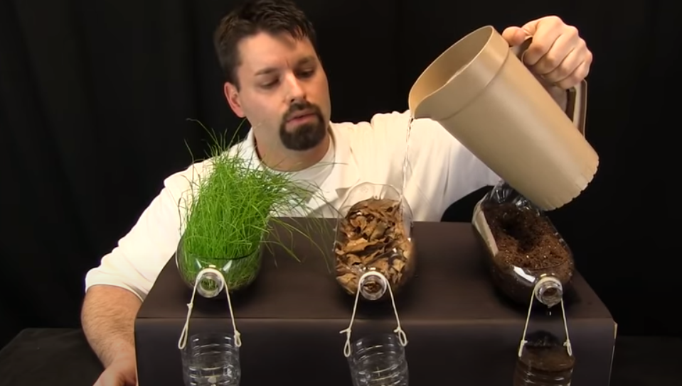
Materials needed:
- Soda and water bottles
- Grass/plant growing in soil
- Leaves, sticks and other debris
- Soil
- String
- Pitcher of water
- Paper
- Pen/pencil

Link to Video: https://www.youtube.com/watch?v=im4HVXMGI68
Steps:
- Explain the goal of this activity, the experiment and materials that will guide this lesson.
- In groups, students make predictions about what will happen when water is poured into each container and which they think will be best for controlling wet weather pollution.
- Using the pitcher, students fill each container with water and observe what comes out of each bottle. Students compare and contrast the results of each container.
- Discuss the results in small groups and as a whole class:
  - Did this match their initial hypothesis?
  - If the results were different, what explains the difference?
  - Thinking about the environment, how does stormwater erosion shape our land?
  - Where do we see this where we live? What can we do in our homes to shape the land we live on and in our communities?

Activity #2: Role of Plants in Water Filtration
Goal: Students will understand the role of plants in filtering water moving through a watershed.

Hypothesis/framing question/framing concept:
- In what ways can plants and soil benefit drinking water quality?
- Will all plants and soil remove impurities from the water? How might the plants remove larger quantities?

Time: 1 hour

Materials needed:
- 6 potted plants, roughly 6-8 in. in diameter, and holes in the bottom
- 6 clear containers, such as cups, which will support the plants and allow drainage
- Unsweetened powdered drink mix, preferably grape/cherry for color
- Soil
- Vegetable oil
- 1 or 2 different household cleaners (i.e. Comet/Ajax and Dish or Laundry soap). One should be liquid and the other powder.

Link to Activity Lesson Plan: https://www.epa.gov/sites/production/files/2016-03/documents/activity_grades_4-8_plantsinwaterfiltration.pdf

Steps:
- Place the potted plants into the top of their cups. Pour clean water slowly through one of the pots and watch it percolate through the bottom of the pot. The water should look as clean as what was poured.
- Add a gram or so of soil to 6-8 ounces of water and stir so that the soil is well suspended and distributed in the water. Pour slowly into another flower pot. The water percolating through should look much cleaner than the dirty water poured.
- Add about one ounce of vegetable oil to 6-8 ounces of water, stir (they won't mix completely) and pour into a third pot. See if the vegetable oil percolates through or is caught up by the plant roots.
- Add some powdered drink mix to 6-8 oz. of water and pour through a fourth pot. See if the water percolating through retains the color.
- Add some powdered cleanser to 6-8 oz. of water and pour through a fifth pot. Is the cleanser retained in the soil?
- Add some liquid soap to the water (an ounce or so in 6-8 oz. water). Does the soap percolate through the soil?
- Using the “contaminated” plants, pour some clean water at the same rate through each one (simulating a rain shower). Is more of the “pollutant” rinsed away from the soil by the clean water?
- Follow up questions:
  - In what ways can plants and soil benefit drinking water quality?
  - Can plants and soil remove any type of impurity from water?
  - What other organisms in the soil-plant system might aid the uptake of water pollutants?
  - What is the role of stormwater moving through contaminated soil?

Video #1: Zoom-A-Water-Scientist: Stormwater & Wastewater
Video link: https://www.youtube.com/watch?v=4SW7beLLYas (52:19)
Discussion questions:
- What are sources of stormwater from your home?
- What are sources of wastewater from your home?
- What is the process of treating wastewater?

Video #2: South Burlington Wastewater Treatment Facility Tour
Video link: https://www.youtube.com/watch?v=Y3-P_Lm36K8 (5:58)
Discussion questions:
- How does the machinery in the treatment facility process wastewater?
- After processing the wastewater, what does the treatment facility test for?
- What are some ways we can help reduce wastewater?

Video #3: Preventing Water Pollution
Video link: https://www.youtube.com/watch?v=XG6tIR7shwE (6:59)
Discussion questions:
- What are some examples of how homes and businesses affect our local waterways?
- What are ways we can prevent pollution from getting into our local waterways?

