Module 1: Water 101
Activity and Video Guide

This module is intended for students in late elementary/middle school.

NGSS Information
MS-ESS2-4. Develop a model to describe the cycling of water through Earth’s systems driven by energy from the sun and the force of gravity.
MS-ESS3-1. Construct a scientific explanation based on evidence for how the uneven distributions of Earth’s minerals, energy, and groundwater resources are the result of past and current geoscience processes.

Concepts covered in informational PowerPoint:
- The water cycle (advanced): For an interactive version of the water cycle with definitions of each phase, please see here: https://water.usgs.gov/edu/watercycle-kids-adv.html
  - How do humans affect the water cycle?
- How geoscience processes shape and change the flow of water
- Fresh water as a limited resource

Activity #1: The Rainmaker
(From The Water Project, https://thewaterproject.org/resources/lesson-plans/rainmaker-experiment)
Hypothesis/framing question/framing concept: What are the stages of the water cycle? Identify the role of the “sun” (heat source) and gravity in the water cycle.
Time: 20 minutes
Materials needed:
- A pan of water
- a burner
- a large cookie sheet
- ice cubes
- 2 metal trash cans
Steps:
- Place a pan of water on the burner.
- Place two metal trash cans on either side of the burner.
- Next, place the cookie sheet on the two trash cans so that it forms a "ceiling" over the pan of water.
- Place the ice cubes on top of the cookie sheet.
- Heat the water and watch as the steam accumulates and hits the cool surface (cookie sheet).
- Record your observations on the Lab Sheet. The water evaporates quickly as it is warmed - rising and condensing as it meets the cooler air above. This creates steam (a cloud). As the condensed water droplets accumulate against the cool surface, they grow in size and fall back to the pan as rain (precipitation).
- Have students identify the three stages of the water cycle: evaporation, condensation, and precipitation. Have students identify the role of the sun’s energy and the force of gravity in the water cycle.

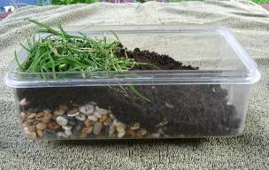
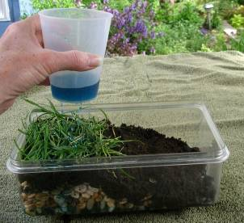
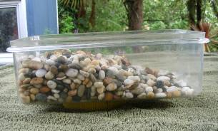
Activity #2: Constructing an Aquifer Model
(From the Science Learning Hub, https://www.sciencelearn.org.nz/resources/805-constructing-an-aquifer-model)
Hypothesis/framing question/framing concept: Where is groundwater stored?
Time: 20 minutes
Materials needed:
- Clear plastic container
- Aquarium stones
- Soil
- Grass clippings
- Plastic cup with small holes in the bottom
- Colored water
- Spray nozzle
- Coffee filter
- Rubber band
- Copies of the steps/directions
Steps:
- Put the aquarium stones in the plastic container. Slope the stones to form a depression at one end of the model. This depression will become a lake or other form of surface water.
- Add a layer of soil on top of the stones. Pat the soil down to minimize erosion.
- Add a layer of grass at the top of the slope to represent vegetation.
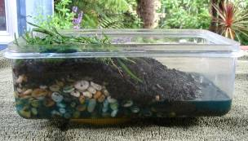
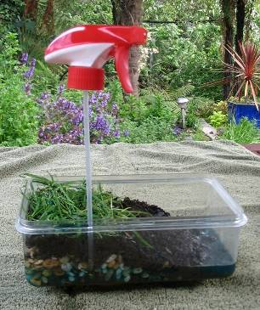
- Hold the cup over the model. Pour some colored water into the cup to simulate rain. Move the cup around so that it rains over the entire model. Refill the cup as needed and continue to rain on the model until a small lake forms.
- Watch what happens to the rain as it falls onto the model. Some of the rain falls onto the soil and runs off into the depression, forming a lake. Some of the rain infiltrates the soil and begins to fill the aquifer. Some rain remains on the surface of the vegetation.
- Look at the lake. It is fed directly by rain, through run-off and also by water moving through the aquifer.
- Stop the rain once the lake is a few centimeters deep. Avoid turning the model into a swamp.
- Look at the water table – the top of the saturated layer. The water table fluctuates depending on how much water enters into or is discharged from the aquifer. The water table rises if more rain falls on the model or falls as water is removed from the system.
- Groundwater is used extensively for drinking water and irrigation. We get groundwater from wells, which are drilled down into the water table. Use a spray pump to represent a well. Cut small strips from the coffee filter. Use these to cover the bottom of the spray nozzle’s tube. Secure the filter with a rubber band. The filter prevents fine particles from entering the tube and plugging the spray nozzle. Work the spray nozzle and ‘pump’ water from the aquifer.

Video #1: Preventing Water Pollution
Video link: https://www.youtube.com/watch?v=XG6tIR7shwE (length: 6:58 minutes)
Note for teacher: This video is applicable to the Water 101 lesson and the Stormwater and Wastewater lesson, although the discussion questions will differ. You may choose to show the video with either of these two lessons.
Discussion questions:
- What does the water cycle look like in Vermont?
- How do human activities and infrastructure impact our local water sources?

Video #2: A Map of Freshwater
Video link: https://youtu.be/bBzt9faOX04 (length: 3:33 minutes)
Discussion questions:
- What geoscience processes were discussed in the video?
- How did the processes affect the distribution of water around the world? How do they continue to do so?
- Using evidence from the video, explain how fresh water is a limited resource. Is it renewable in the short term? In the long term?
- How do humans contribute to the distribution of fresh water? Consider human impacts caused by irrigation for farming and the use of fossil fuels.

Video #3: How Much Water Do You Use Each Day?
Video link: https://www.youtube.com/watch?v=olmKly4U1X0 (length: 6:02 minutes)
Framing: The water that we use for our day-to-day needs is fresh water, which makes up only 3% of the Earth’s water supply. Water is a limited resource. What do you use water for? How can you conserve water?
Discussion questions:
- What activities do you typically use water for in a day?
- Based on what you learned, how much water do those activities use (in gallons)?
- How do your activities affect the earth’s water supply? What are ways you can conserve water?

