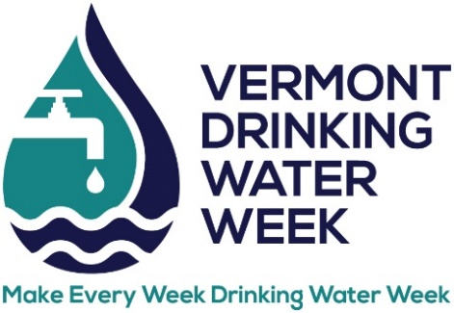
DRINKING WATER TASTE CONTEST
ENTRY FORM

Think you have the best tasting water in Vermont? Enter the 2023 Drinking Water Taste Test which will be held during Vermont Rural Water’s Annual Conference at Lake Morey Resort.

Date: Thursday, May 11, 2023
Time: Deliver samples by 9 am. Judging starts at 9:30 am.
Location: Lake Morey Resort, 82 Clubhouse Rd, Fairlee, VT

Name of system: _________________________________

WSID: ________________ _________________________________________

Contact name: ______________________________________________________

Phone number: ________________________________ ____________________

Email: _________________ ___________________________________

Category (circle one):

CWS – Surface Water CWS – Groundwater NTNC TNC

Please send form to info@vtruralwater.org by April 28

Remember:
- Provide one (1) gallon of water in a container that is clearly marked with water system name, WSID, type of system (CWS groundwater, CWS surface water, NTNC or TNC), and contact person on each container. Glass containers are strongly recommended.
- Drop off your sample at the taste test table in the lobby by 9 am on May 11.
- Samples should be drawn no earlier than the day before the contest.

